CO1 AT3 Experiments

Experiment 1: Learning Algorithm (Linear Regression)
Aim
To implement Linear Regression using Gradient Descent and analyze convergence.

Algorithm
- Initialize weights and bias.
- Compute predictions.
- Calculate loss (MSE).
- Update weights using gradient descent.
- Repeat until convergence.

Code
import numpy as np
import matplotlib.pyplot as plt

# Data
X = np.array([1,2,3,4,5])
Y = np.array([2,4,6,8,10])

w, b = 0, 0
lr = 0.01
losses = []

for i in range(100):
y_pred = w*X + b
loss = np.mean((Y - y_pred)**2)
losses.append(loss)

dw = -2*np.mean(X*(Y - y_pred))
db = -2*np.mean(Y - y_pred)

w -= lr*dw
b -= lr*db

plt.plot(losses)
plt.title("Loss Curve")
plt.show()

Output
- Loss decreases over iterations
- Final line fits data (y ≈ 2x)
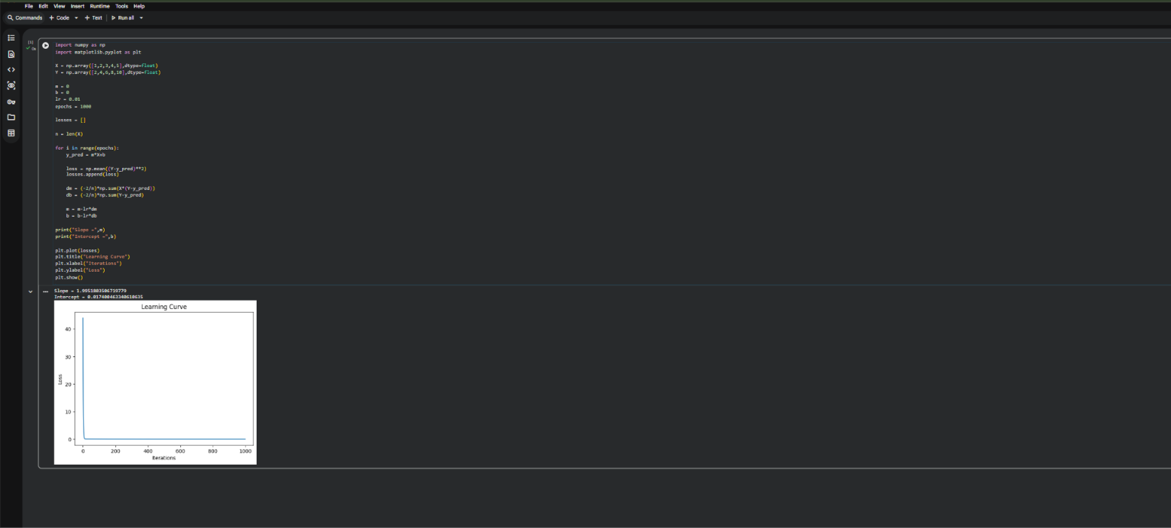

Experiment 2: MLE (Normal Distribution)

Aim
Estimate mean and variance using MLE.

Algorithm
- Generate dataset.
- Compute mean = average.
- Compute variance = squared deviation.

Code
import numpy as np

data = np.random.normal(5, 2, 1000)

mu = np.mean(data)
var = np.var(data)

print("Estimated Mean:", mu)
print("Estimated Variance:", var)

Output
- Estimated mean ≈ 5
- Estimated variance ≈ 4

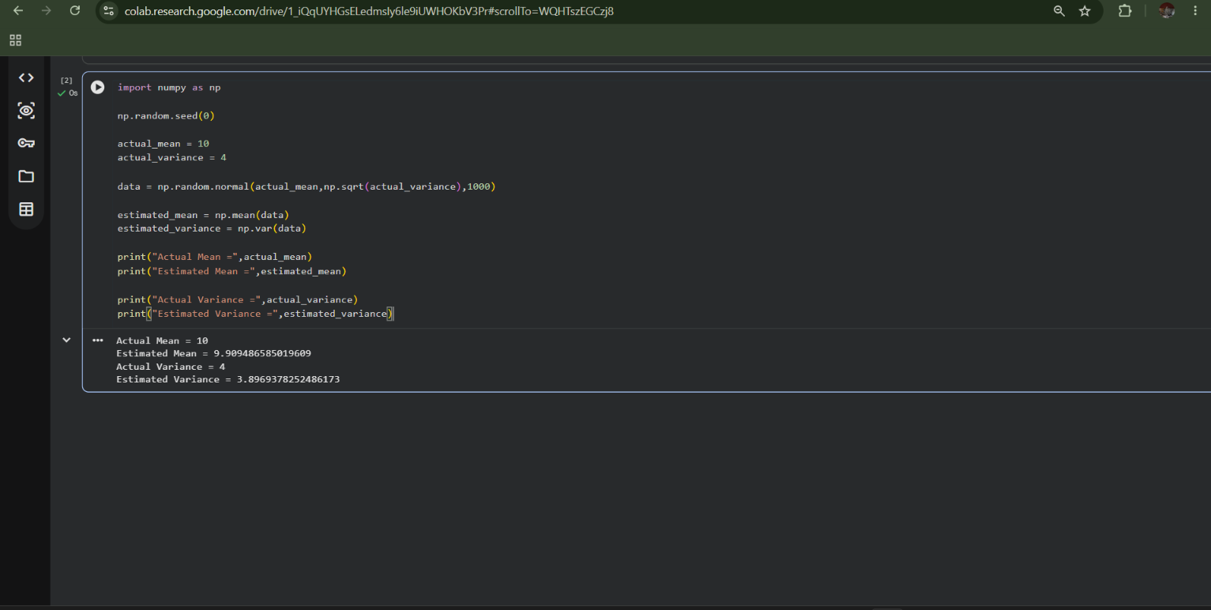

Experiment 3: ML Pipeline

Aim
Build a classification model and evaluate performance.

Algorithm
- Load dataset
- Split data
- Train model
- Evaluate accuracy

Code
from sklearn.datasets import load_iris
from sklearn.model_selection import train_test_split
from sklearn.linear_model import LogisticRegression
from sklearn.metrics import accuracy_score

data = load_iris()
X_train,X_test,y_train,y_test = train_test_split(data.data,data.target,test_size=0.2)

model = LogisticRegression(max_iter=200)
model.fit(X_train,y_train)

y_pred = model.predict(X_test)
print("Accuracy:", accuracy_score(y_test,y_pred))

Output
- Accuracy ≈ 90–100%
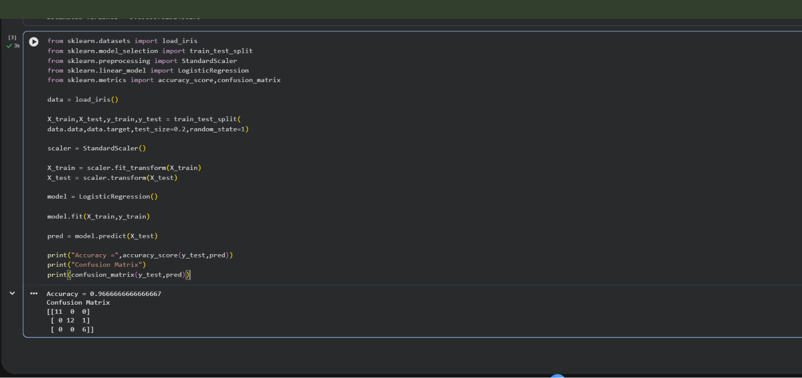

Experiment 4: Neural Network

Aim
Train a simple neural network.

Code
from sklearn.neural_network import MLPClassifier
from sklearn.datasets import load_iris

data = load_iris()
model = MLPClassifier(hidden_layer_sizes=(5,), max_iter=500)
model.fit(data.data, data.target)

print("Training Complete")

Output
- Model learns non-linear patterns
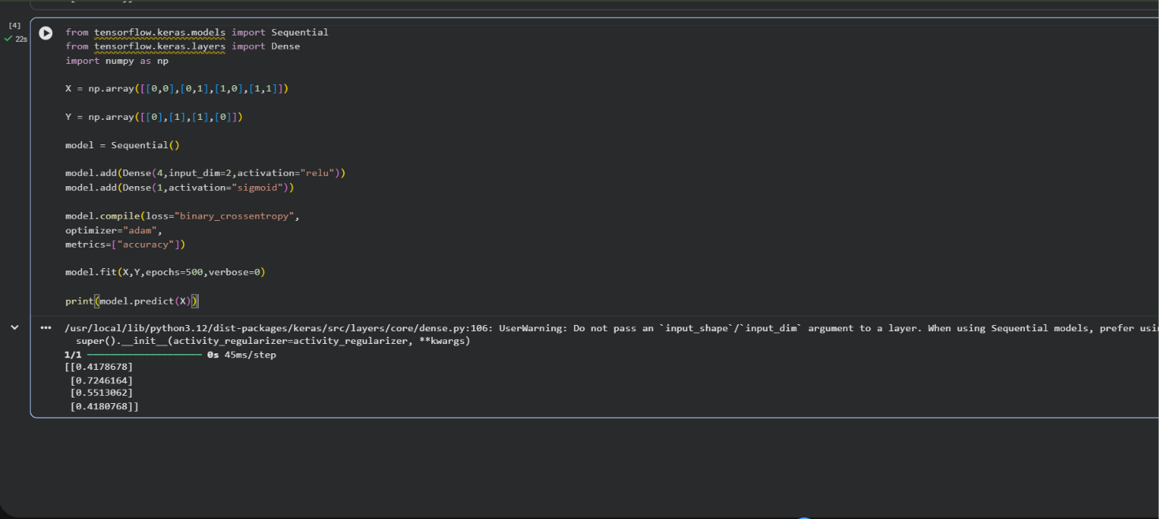

Experiment 5: Artificial Neuron

Aim
Implement neuron with activation functions.

Code
import numpy as np

x = np.array([1,2,3])
w = np.array([0.5,0.5,0.5])
z = np.dot(x,w)

sigmoid = 1/(1+np.exp(-z))
relu = max(0,z)

print("Sigmoid:", sigmoid)
print("ReLU:", relu)

Output
- Different outputs for different activations
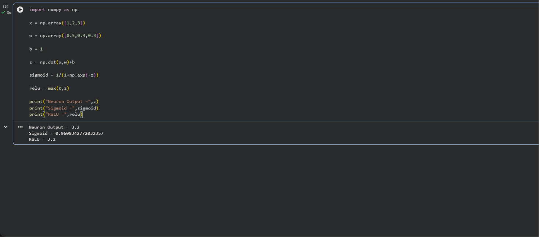

Experiment 6: Perceptron

Aim
Implement Perceptron.

Code
from sklearn.linear_model import Perceptron
from sklearn.datasets import make_classification

X,y = make_classification(n_samples=100,n_features=2,n_classes=2,n_redundant=0)

model = Perceptron()
model.fit(X,y)

print("Accuracy:", model.score(X,y))

Output
- Works well for linearly separable data
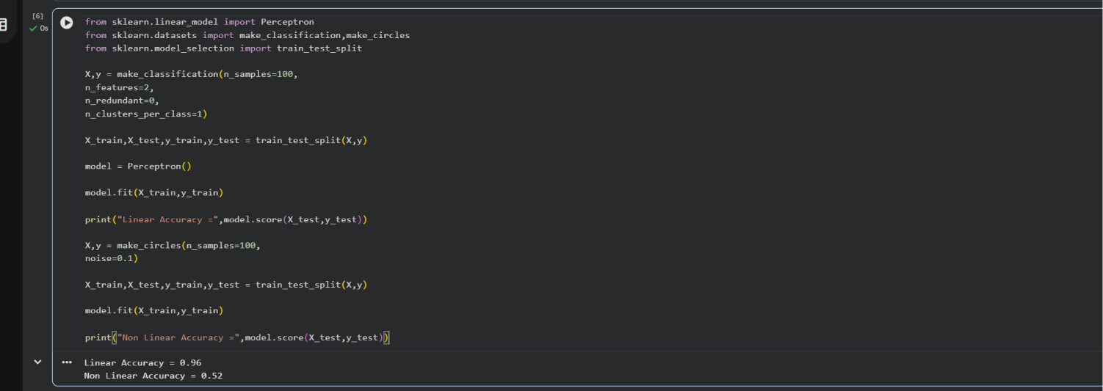

Experiment 7: MLP

Aim
Compare MLP vs Perceptron.

Code
from sklearn.neural_network import MLPClassifier

model = MLPClassifier(hidden_layer_sizes=(10,), max_iter=500)
model.fit(X,y)

print("MLP Accuracy:", model.score(X,y))

Output
- MLP performs better for complex data
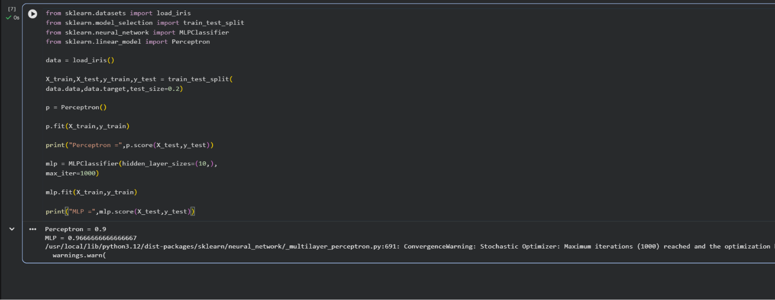

Experiment 8: Forward Propagation

Aim
Compute forward pass manually.

Code
import numpy as np

X = np.array([1,2])
W = np.array([[0.5,0.2],[0.3,0.7]])

Z = np.dot(X,W)
A = 1/(1+np.exp(-Z))

print("Output:", A)

Output
- Activation values of network
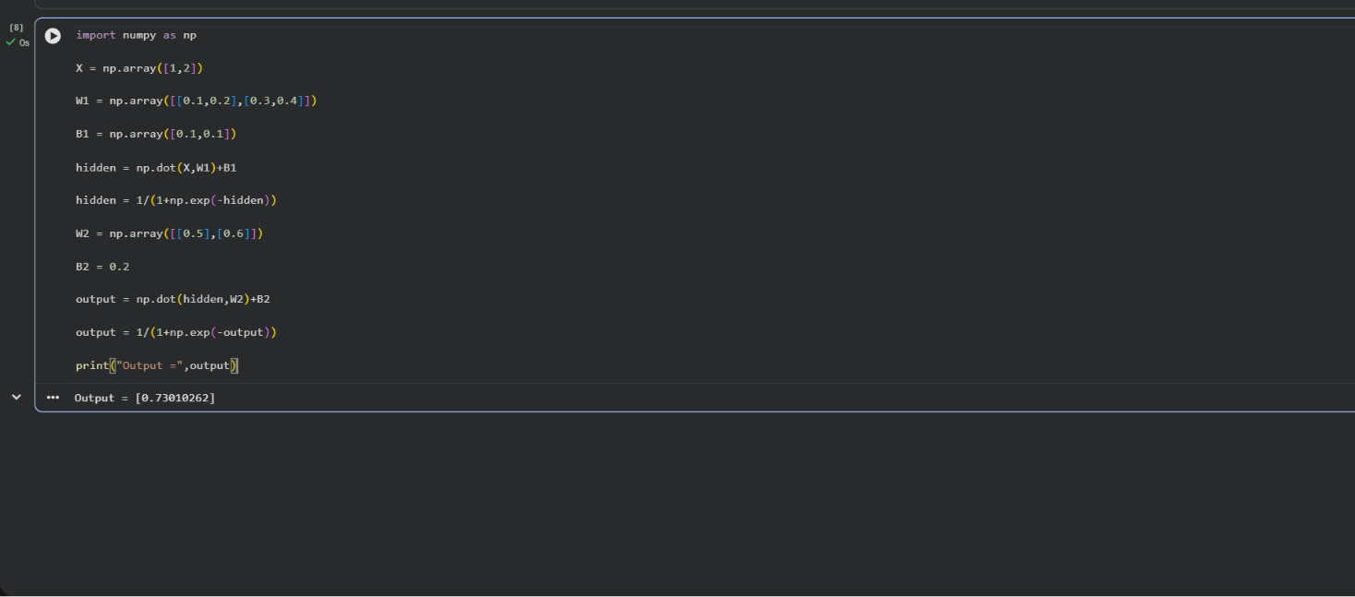

Experiment 9: Backpropagation

Aim
Update weights using gradients.

Code
w = 0.5
x = 2
y_true = 4

y_pred = w*x
loss = (y_true - y_pred)**2

grad = -2*x*(y_true - y_pred)
w = w - 0.01*grad

print("Updated weight:", w)

Output
- Weight updated toward minimizing error
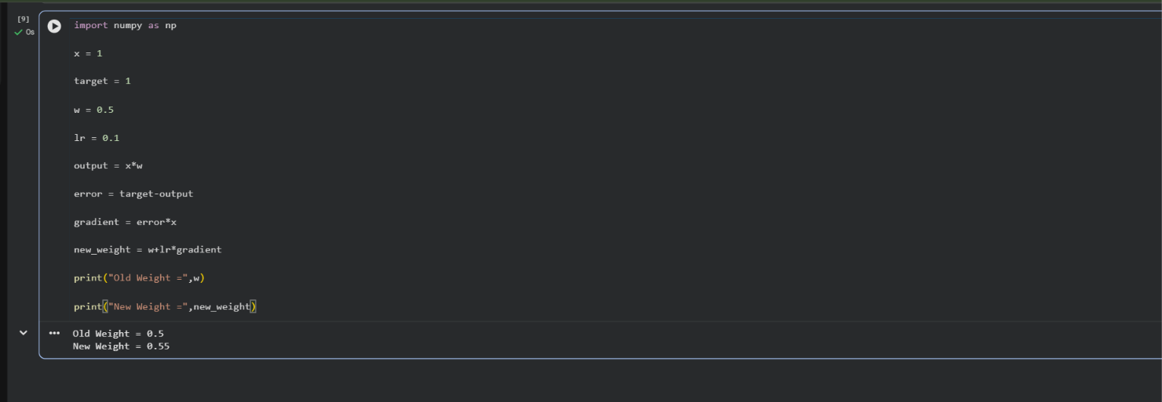

Experiment 10: Gradient Descent

Aim
Minimize cost function.

Code
x = 5
for i in range(10):
grad = 2*x
x = x - 0.1*grad
print(x)

Output
- x approaches minimum (0)
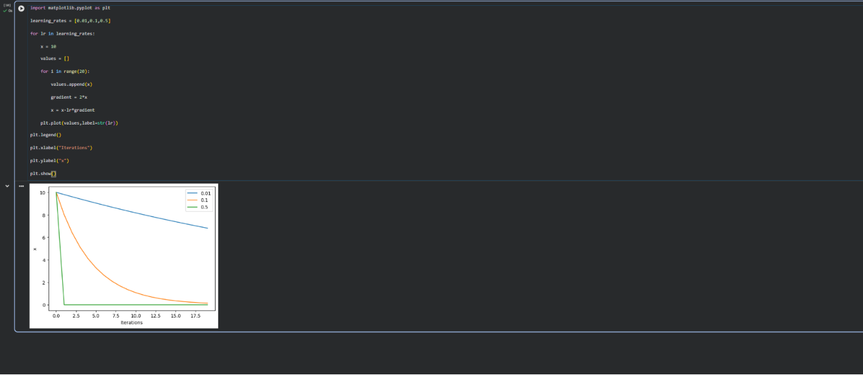

Experiment 11: SGD

Aim
Implement Stochastic Gradient Descent.

Code
import numpy as np

X = np.array([1,2,3])
Y = np.array([2,4,6])

w = 0
lr = 0.01

for i in range(10):
for j in range(len(X)):
y_pred = w*X[j]
grad = -2*X[j]*(Y[j]-y_pred)
w -= lr*grad

print("Weight:", w)

Output
- Faster but noisy convergence
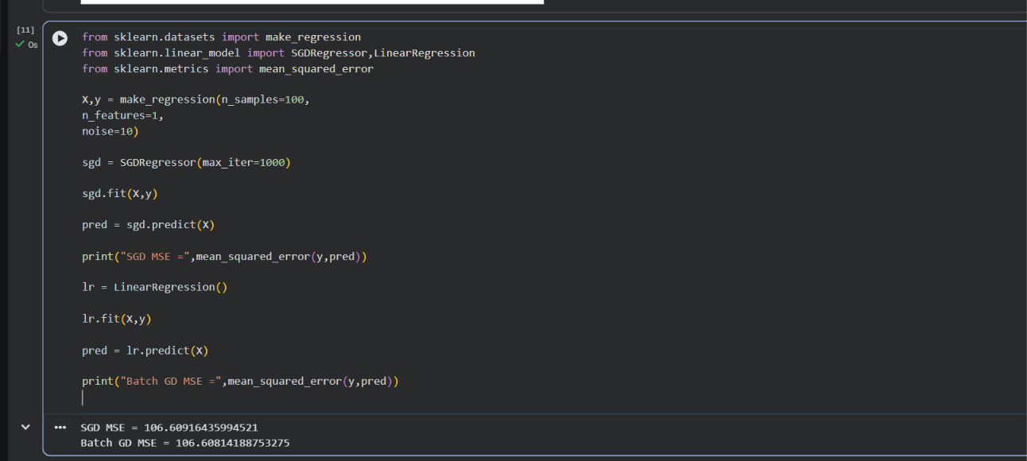

Experiment 12: Mini-Batch GD

Aim
Train using mini-batches.

Code
batch_size = 2
for i in range(0,len(X),batch_size):
xb = X[i:i+batch_size]
yb = Y[i:i+batch_size]

y_pred = w*xb
grad = -2*np.mean(xb*(yb-y_pred))
w -= 0.01*grad

print("Weight:", w)

Output
- Balanced convergence
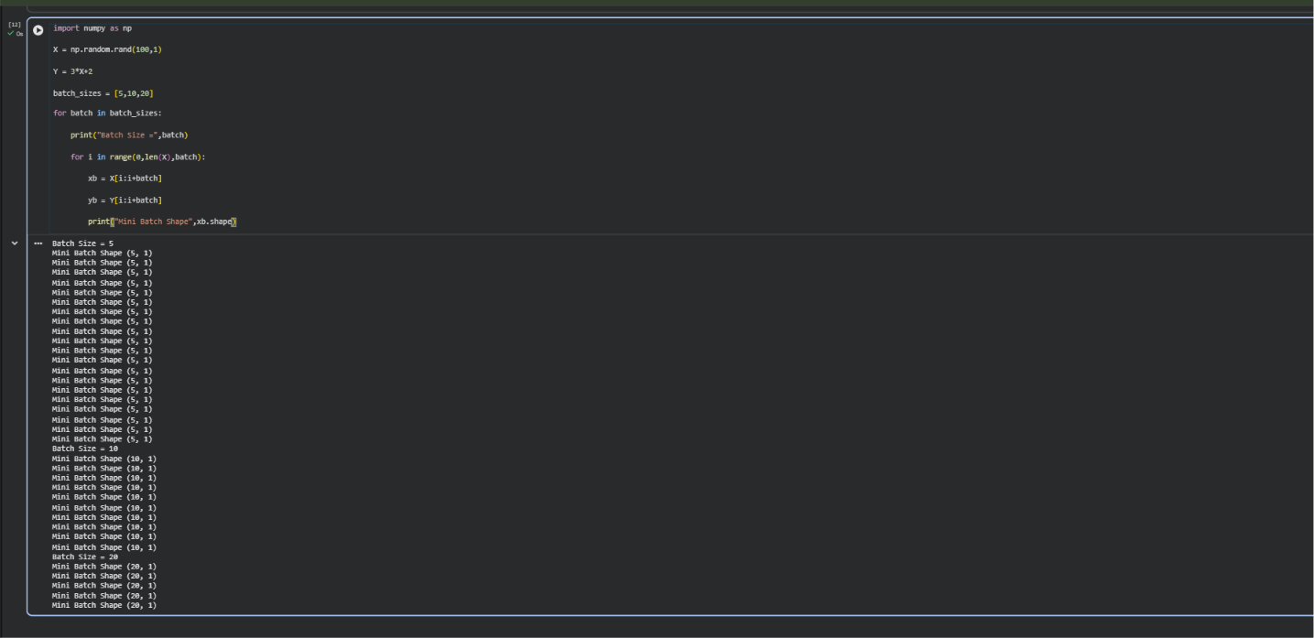

Experiment 13: Curse of Dimensionality

Aim
Analyze effect of increasing dimensions.

Code
from sklearn.neighbors import KNeighborsClassifier
from sklearn.datasets import make_classification

for d in [2,5,10,20]:
X,y = make_classification(n_samples=200,n_features=d)
model = KNeighborsClassifier()
model.fit(X,y)
print("Dim:", d, "Accuracy:", model.score(X,y))

Output
- Accuracy decreases as dimensions increase
